SPORT MILTON KEYNES

SPORTS ACHIEVER

OF THE YEAR AWARDS



NOMINATION FORM FOR
ACHIEVEMENT IN SPORT
FOR THE YEAR 2019

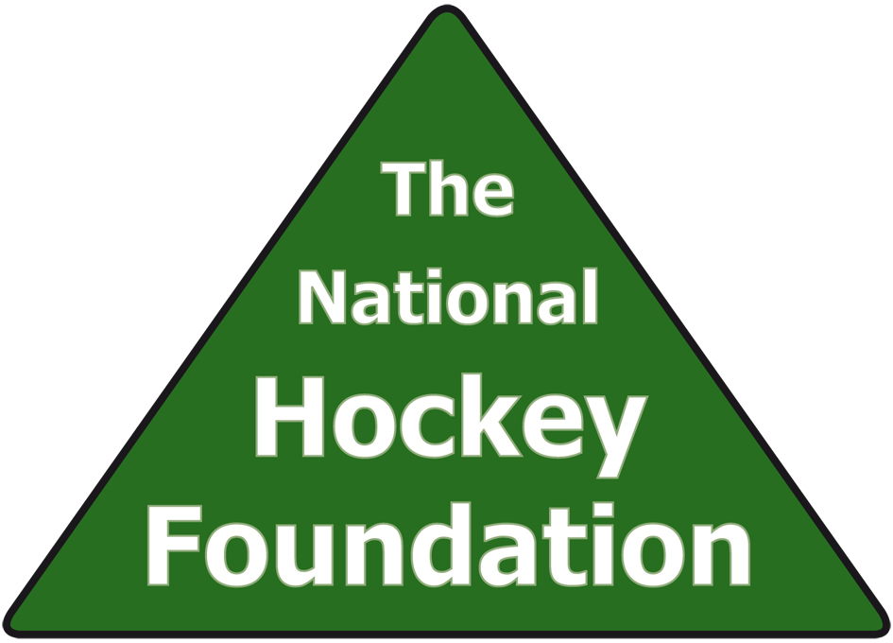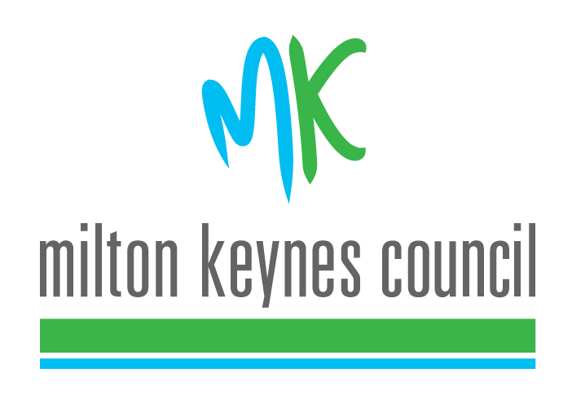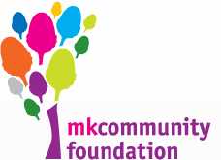


PURPOSE OF THE AWARDS

To recognise outstanding amateur achievements in Sport, either through outstanding personal performance or through a contribution an individual may make as an organiser and administrator to the development of participation or standards of performance in Sport during 2019

CATEGORIES OF AWARD

a) Boys’ Award for Achievement in Sport for those under 18 years of age on 31st December 2019
b) Girls’ Award for Achievement in Sport for those under 18 years of age on 31st December 2019
c) Men’s Award for Achievement in Sport for those 18 years of age and over on 1st January 2019
d) Women’s Award for Achievement in Sport for 18 years of age and over on 1st January 2019
- Award for Disabled Men and Boys for Achievement in Sport
- Award for Disabled Women and Girls for Achievement in Sport
- Masters Award for Men
- Masters Award for Women
- Award for Schools (Primary)
- Award for Schools (Secondary)
k) Award for Special School
l) Award for Coach of the Year 2019
m) Service to Sport Award for those of any age who have given long and outstanding
service to a specific sport or collection of sports.
n) Award for Team of the Year 2019
o) Award for Club of the Year 2019
p) Volunteer of the Year 2019
q) Sports Person of the Year 2019
r) Harry Hewitt Memorial Trophy 2019 (This is awarded to an athlete who has shown outstanding improvement over the past year)

SELECTION REGULATIONS
A representative adjudication panel will select the winners in October 2019 and the presentation will take place on Tuesday 3rd December 2019 at Denbigh Theatre, Shenley Leisure Centre, Burchard Crescent, Shenley Church End, Milton Keynes MK5 6HF

Nominated players and officials must reside within Milton Keynes or represent a Milton Keynes based organisation.

Winner of each category may be required to give an interview and have his/her photograph taken by a representative of Sport Milton Keynes during November 2019

Each category winner will be required to attend the Sports Achiever Awards Evening in Milton Keynes on Tuesday 3rd December 2019 at Denbigh Theatre, Shenley Leisure Centre, Burchard Crescent, Shenley Church End, Milton Keynes MK5 6HF. Each individual winner may bring up to four guests. For any clubs or school, a maximum of 12 guests can be invited.

Category winners will be informed mid November 2019

NOMINATION FORMS MUST BE RETURNED

By e-mail to; sportmiltonkeynes@gmail.com

NO LATER THAN FRIDAY 19th OCTOBER 2018

SPORT:MK
ACHIEVEMENT IN SPORT 2019

The nomination form is split into 4 parts. Under GDPR (Data Protection) any information supplied will only be used to contact persons in relation to the Sports Achiever of the Year awards.
Section 1 – Candidate information
Name of Candidate:-
Address:-

Tel. No. (day): Tel. No. (eve):
Mobile: Email:
Date of Birth:- (If under 18)
State any clubs of which the Candidate is a member:

Section 2 Person Submitting Nomination
Name of Nominator: -

Status of Nominator: -

Address: -

Tel. No. (day): Tel. No. (eve):
Mobile: Email:
Section 3 Listing of Major Achievements in Sport During 2019
Please specify whether achievements cover open or closed age categories
Local or District: -

County: -

Regional: -

National/International: -

Section 4 Supporting Information
Any other relevant information including achievement and commitment to one or more sports.
Information must be submitted on this form only and not more than 300 words.

PLEASE REMEMBER THAT SELECTION OF WINNERS IS BASED ONLY ON INFORMATION CONTAINED IN THIS NOMINATION PAPER. YOUR SUBMISSION MUST, THEREFORE, BE AS COMPREHENSIVE AS POSSIBLE.

INFORMATION MUST BE SUBMITTED ON THIS FORM, COMMENTS ON SEPARATE PAPER WILL BE DISREGARDED

Winners may be asked, if they are agreeable to supply videos or photographs to be used on the presentation evening.

Name signed: Name Print

Relationship to nominee

*Under 18-year olds involved in the Sports Achiever awards may be photographed in connection with their award. Are you happy for pictures of your son/daughter to appear on Sport Milton Keynes Display Boards or in publications such as leaflets, posters, newspaper articles etc concerned with Sport Milton Keynes?

Where possible anonymity will be protected. YES/NO (Please circle as appropriate)

Name signed: Name print

Nomination form to be returned to: e-mail sportmiltonkeynes@gmail.com

NO LATER THAN Monday 14th OCTOBER 2019

